**Designing The SetPaperFrame**

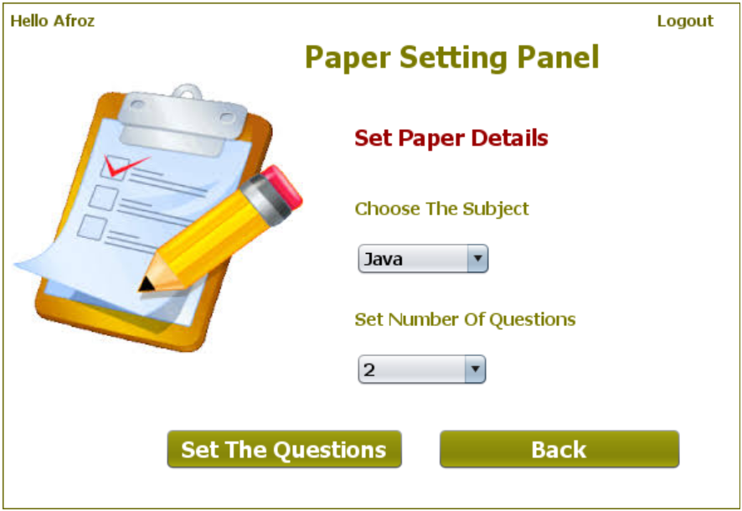

**STEPS TO BE DONE IN** **SetPaperFrame**

In the **SetPaperFrame** we need to do following steps:

1. Display **username** on the top left

2. Allow the user to **logout**

3. Write code for the "**Set Questions**" Button. When this button is clicked it should:

a.Generate an **Exam-Id**

b.Pass the **Exam** details(**Exam Id**,**subject**,**total no of questions**) to the **SetQuestionsFrame**

4. When the "**Back**" button is clicked we must go back to the **AdminOptionsFrame**

**Displaying The Username**

Same as **AdminOptionsFrame**

**Allowing The User To Logout**

Same as **AdminOptionsFrame**

**THE TABLE USED IN SetPaperFrame**

**EXAM:**

|  |  |  |
| --- | --- | --- |
| **Column Name** | **Data Type** | **Description** |
| **EXAMID** | **Varchar2(10)** | **Contains id of the paper** |
| **LANGUAGE** | **Varchar2(10)** | **Contains the programming language name** |
| **TOTAL_QUESTION** | **Number(4)** | **Contains total number of question present** |

**WRITING THE CODE FOR BUTTON Button.png IN SetPaperFrame**

**Generating The Exam-Id**

To generate the **Exam-Id** , we use a simple logic:

**a. Find out number of rows in the EXAM Table**

**b. Add 1 to rowcount and prefix it with "EX" which is the new Exam-Id. For example if total rows in the EXAM Table is 3 then next Exam-Id will be "EX-4"**

**How To Find Number Of Rows**

To find number of rows in the **EXAM** Table we do the following:

a. Create the **ExamDAO** class with a method called **getExamId( )**.

b. This method should execute the following SQL query:

***Select count(*) as totalrows from Exam***

and return value of **count(*) +1** as the **Exam-Id** prefixed with "**EX**"

c. So the prototype of the method is:

***public static String getExamId()throws SQLException***

**Opening The SetQuestionsFrame**

To open the **SetQuestionsFrame** we need to pass it the **Exam** details. This is done as follows:

**a. Create a POJO class called ExamPojo**

**b. Create an object of ExamPojo and store Exam-Id, language and total questions in it.**

**c. Pass it to the SetQuestionsFrame constructor**

**d. Dispose the current Frame**